What will we be learning?  Unit FO94 – Supporting people with mental health conditions | Why this? Why now?  This unit is completed in Year 13. It is an optional unit. It runs alongside F091 the examined unit and F097 coursework unit during Year 13. | Key Words/terms:  Neurological  Degenerative  Autoimmune  Hereditary  Redisposition  Discrimination  Primary care  Secondary care  Third Sector  Domiciliary care agencies  Practitioner  NICE
What will we learn?
- TA1 – Types of long-term physiological conditions
- TA2 – Monitoring and treatment
- TA3 – Impact of long-term conditions
- TA4 – Support individuals to plan their care and support

What opportunities are there for wider study?
Careers/degree courses
- Social care
- Childcare
- Health care

Further reading:
Describe different working relationships in care settings – DSDWEB: FREE STUDY GUIDES FOR CARE QUALIFICATIONS
Timeline of Baby P case - BBC News
Inquiry investigates deaths of 1,500 NHS mental health patients in Essex | Mental health | The Guardian
How will I be assessed?
- OCR set assignments on Teams.
AAQ – HEALTH & SOCIAL CARE
UNIT F094

TA1 – LONG-TERM PHYSIOLOGICAL CONDITIONS  - Types of physiological conditions  - Causes of long-term physiological conditions  - Signs and symptoms of long-term physiological conditions | 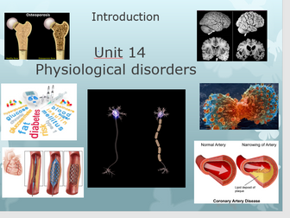
TA2 – MONITORING AND TREATMENT  2.1 Monitoring  2.2 Treatment  2.3 Barriers to accessing treatment  2.4 Future developments for the condition | 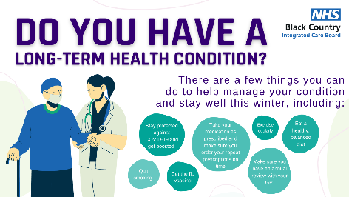
TA3 – IMPACT OF LONG-TERM CONDITIONS  - Daily impacts  - Long term impacts | 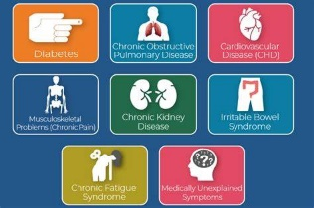
TA4 – SUPPORT INDIVIDUALS TO PLAN THEIR CARE AND SUPPORT  - Service provision  - Practitioners  - NICE guidelines to support individuals | 